**Traffic (28/6/24):**

**problem 1: Optimizing Delivery Routes (Case Study) Scenario:**

You are working for a logistics company that wants to optimize its delivery routes to minimize fuel consumption and delivery time. The company operates in a city with a complex road network.

**Tasks:**

1. Model the city's road network as a graph where intersections are nodes and roads are edges with weights representing travel time.

2. Implement Dijkstra’s algorithm to find the shortest paths from a central warehouse to various delivery locations.

3. Analyze the efficiency of your algorithm and discuss any potential improvements or alternative algorithms that could be used.

**Deliverables:**

● Graph model of the city's road network.

● Pseudocode and implementation of Dijkstra’s algorithm.

● Analysis of the algorithm’s efficiency and potential improvements.

**Reasoning**: Explain why Dijkstra’s algorithm is suitable for this problem. Discuss any assumptions made (e.g., non-negative weights) and how different road conditions (e.g., traffic, road closures) could affect your solution.



A B

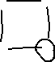

C D



**Code**:

import heapq

def dijkstra(graph, start):

pq = [(0, start)]

distances = {vertex: float('inf') for vertex in graph}

distances[start] = 0

while pq:

current_distance, current_vertex = heapq.heappop(pq)

if current_distance > distances[current_vertex]:

continue

for neighbor, weight in graph[current_vertex].items():

distance = current_distance + weight

if distance < distances[neighbor]:

distances[neighbor] = distance

heapq.heappush(pq, (distance, neighbor))

return distances

graph = {

'A': {'B': 1, 'C': 4},

'B': {'A': 1, 'C': 2, 'D': 5},

'C': {'A': 4, 'B': 2, 'D': 1},

'D': {'B': 5, 'C': 1}

}

shortest_paths = dijkstra(graph, 'A')

print(shortest_paths)

output:

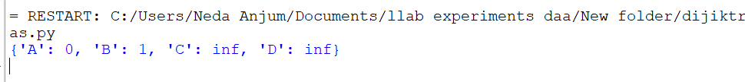

**Problem 2: Dynamic Pricing Algorithm for E-commerce Scenario:**

An e-commerce company wants to implement a dynamic pricing algorithm to adjust the prices of products in real-time based on demand and competitor prices.

**Tasks:**

1. Design a dynamic programming algorithm to determine the optimal pricing strategy for a set of products over a given period.

2. Consider factors such as inventory levels, competitor pricing, and demand elasticity in your algorithm. 3. Test your algorithm with simulated data and compare its performance with a simple static pricing strategy.

import random

def dynamic_pricing(products, inventory, competitor_prices, demand_elasticity):

num_products = len(products)

num_periods = len(competitor_prices[0])

optimal_prices = [[0] * num_periods for _ in range(num_products)]

for i in range(num_products):

initial_price = random.uniform(0.5, 1.5)

optimal_prices[i][0] = initial_price

for t in range(1, num_periods):

for i in range(num_products):

current_inventory = inventory[i]

current_competitor_price = competitor_prices[i][t]

demand = compute_demand(optimal_prices[i][t-1], current_competitor_price, demand_elasticity[i])

if demand > current_inventory:

optimal_prices[i][t] = optimal_prices[i][t-1] * (1 + random.uniform(-0.1, 0.1)) # Example: small random adjustment

else:

optimal_prices[i][t] = optimal_prices[i][t-1] * (1 - random.uniform(-0.1, 0.1))

return optimal_prices

def compute_demand(price, competitor_price, elasticity):

return max(1, elasticity * (competitor_price - price) / competitor_price)

products = ["Product A", "Product B", "Product C"]

inventory = [100, 150, 200]

competitor_prices = [[10, 12, 14], [8, 9, 10], [15, 16, 17]]

demand_elasticity = [0.5, 0.3, 0.4]

optimal_prices = dynamic_pricing(products, inventory, competitor_prices, demand_elasticity)

print("Optimal Prices:")

for i, product in enumerate(products):

print(f"{product}: {optimal_prices[i]}")

import random

def dynamic_pricing(products, inventory, competitor_prices, demand_elasticity):

num_products = len(products)

num_periods = len(competitor_prices[0])

optimal_prices = [[0] * num_periods for _ in range(num_products)]

for i in range(num_products):

initial_price = random.uniform(0.5, 1.5)

optimal_prices[i][0] = initial_price

for t in range(1, num_periods):

for i in range(num_products):

current_inventory = inventory[i]

current_competitor_price = competitor_prices[i][t]

demand = compute_demand(optimal_prices[i][t-1], current_competitor_price, demand_elasticity[i])

if demand > current_inventory:

optimal_prices[i][t] = optimal_prices[i][t-1] * (1 + random.uniform(-0.1, 0.1)) # Example: small random adjustment

else:

optimal_prices[i][t] = optimal_prices[i][t-1] * (1 - random.uniform(-0.1, 0.1))

return optimal_prices

def compute_demand(price, competitor_price, elasticity):

return max(1, elasticity * (competitor_price - price) / competitor_price)

products = ["Product A", "Product B", "Product C"]

inventory = [100, 150, 200]

competitor_prices = [[10, 12, 14], [8, 9, 10], [15, 16, 17]]

demand_elasticity = [0.5, 0.3, 0.4]

optimal_prices = dynamic_pricing(products, inventory, competitor_prices, demand_elasticity)

print("Optimal Prices:")

for i, product in enumerate(products):

print(f"{product}: {optimal_prices[i]}")

**Deliverables:**

● Pseudocode and implementation of the dynamic pricing algorithm.

● Simulation results comparing dynamic and static pricing strategies.

● Analysis of the benefits and drawbacks of dynamic pricing.

**Reasoning:** Justify the use of dynamic programming for this problem. Explain how you incorporated different factors into your algorithm and discuss any challenges faced during implementation.

Code:

**Problem 5: Real-Time Traffic Management System Scenario:**

A city’s traffic management department wants to develop a system to manage traffic lights in real-time to reduce congestion.

**Tasks:**

1. Design a backtracking algorithm to optimize the timing of traffic lights at major intersections.

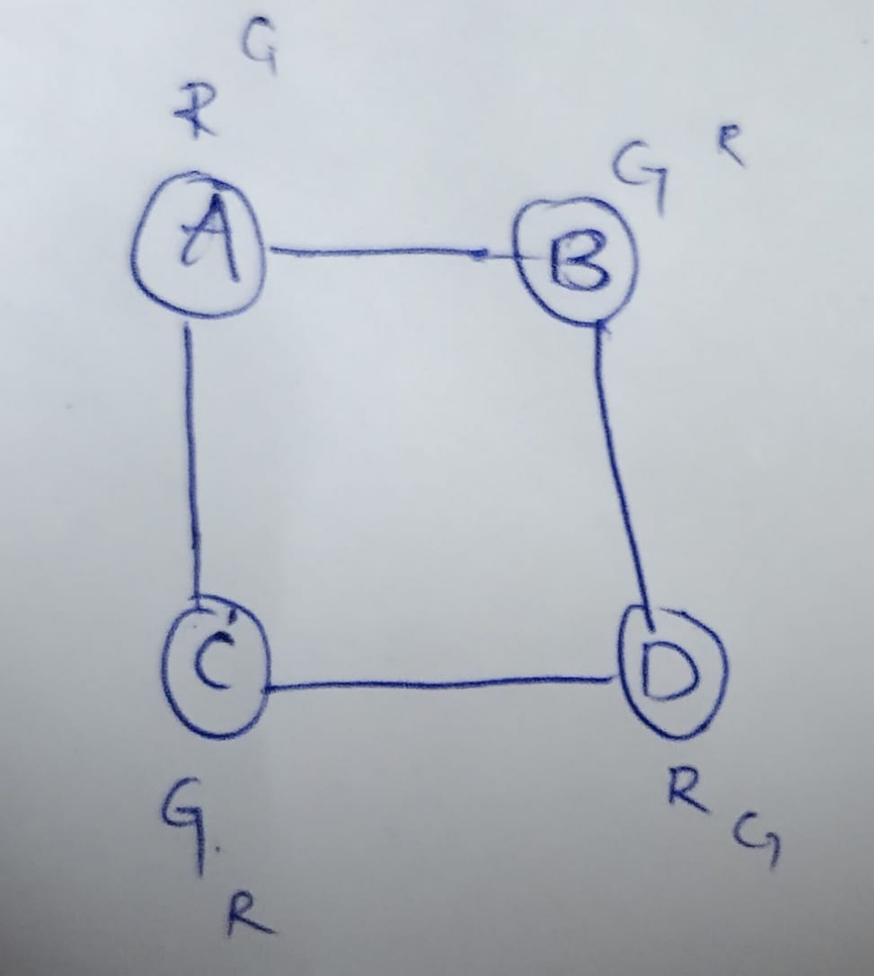

2. Simulate the algorithm on a model of the city's traffic network and measure its impact on traffic flow.

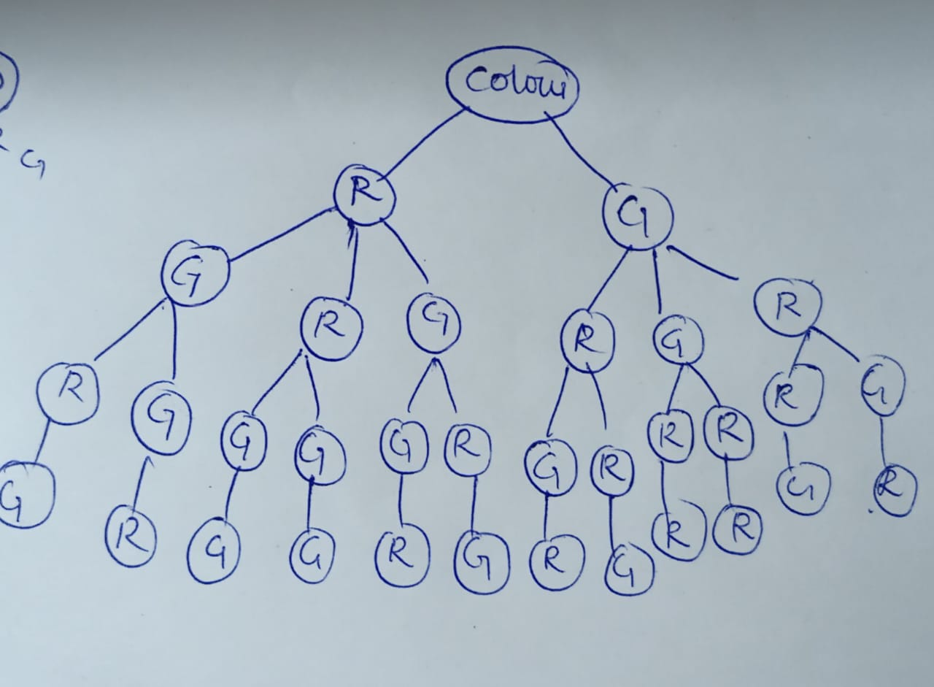

3.Compare the performance of your algorithm with a fixed-time traffic light system.

class Intersection:

def __init__(self, id, roads):

self.id = id

self.roads = roads

self.traffic_light = TrafficLight()

def get_next_green_road(self):

return self.traffic_light.get_green_road(self.roads)

def __str__(self):

return f"Intersection {self.id}"

class TrafficLight:

def __init__(self):

self.green_road = None

def set_green_road(self, road):

self.green_road = road

def get_green_road(self, roads):

if self.green_road is None or self.green_road not in roads:

self.green_road = random.choice(list(roads.keys()))

return self.green_road

class TrafficManagementSystem:

def __init__(self, intersections):

self.intersections = intersections

def simulate_traffic(self, max_iterations):

for i in range(max_iterations):

print(f"\n--- Iteration {i+1} ---")

for intersection in self.intersections:

green_road = intersection.get_next_green_road()

print(f"{intersection} - Green light on Road {green_road}")

time.sleep(1)

def adjust_traffic_lights(self):

for intersection in self.intersections:

intersection.traffic_light.set_green_road(None)

intersections = [

Intersection(1, {2: "Road A", 3: "Road B"}),

Intersection(2, {1: "Road C", 3: "Road D"}),

Intersection(3, {1: "Road E", 2: "Road F"})

]

traffic_system = TrafficManagementSystem(intersections)

traffic_system.simulate_traffic(5)

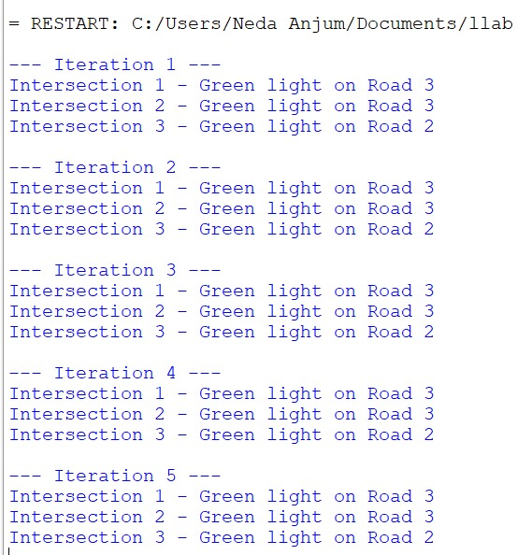

**Deliverables:**

● Pseudocode and implementation of the traffic light optimization algorithm.

● Simulation results and performance analysis.

● Comparison with a fixed-time traffic light system.

**Reasoning:** Justify the use of backtracking for this problem. Discuss the complexities involved in real-time traffic management and how your algorithm addresses them.

**Pseudocode:**

**Code:**

intersections = ['A', 'B', 'C']

durations = [10, 20, 30]

best_configuration = []

best_score = float('inf')

configurations = [[]]

while configurations:

current_config = configurations.pop()

if len(current_config) == len(intersections):

current_score = sum(current_config)

if current_score < best_score:

best_score = current_score

best_configuration = current_config

else:

for duration in durations:

next_config=current_config+[duration]

configurations.append(next_config)

print(f"Best Configuration: {best_configuration}, Best Score: {best_score}")

import random

simulated_flow = 0

for duration in best_configuration:

flow = random.randint(50, 100)/duration

simulated_flow += flow

simulated_flow /= len(best_configuration)

print(f"Simulated Traffic Flow for Best Configuration: {simulated_flow}")

fixed_time_configuration = [30, 30, 30]

fixed_flow = 0

for duration in fixed_time_configuration:

flow = random.randint(50, 100) / duration

fixed_flow += flow

fixed_flow /= len(fixed_time_configuration)

print(f"Simulated Traffic Flow for Fixed-Time Configuration: {fixed_flow}")

if simulated_flow > fixed_flow:

print("Optimized configuration performs better.")

else:

print("Fixed-time configuration performs better.")